KINGSBURY INDIANA / DEVELOPMENT PROPOSAL / 01

Kingsbury LTO development proposal
A proposed Indiana campus for qualified battery materials, high power cells and energy storage systems.
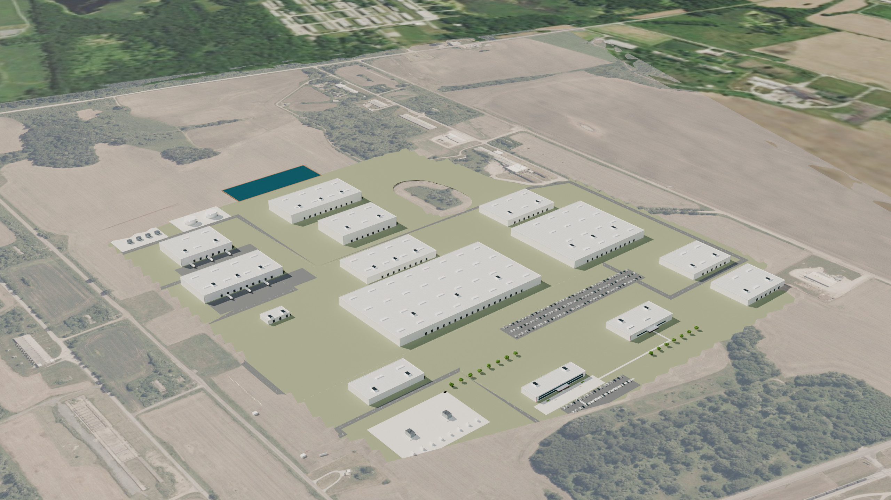
$35 million First proposed authorization for diligence and qualification design | Kingsbury Indiana Reference campus on S 5th Line Road in LaPorte County | 50 MWh pilot Qualification first, with commercial expansion behind evidence
Milieu Minerals portfolio | Milieu Power program | Proposed campus rendered from controlled site geometry. No construction authorization or supply contract is assumed.

KINGSBURY INDIANA / DEVELOPMENT PROPOSAL / 02

An investable first step in northwest Indiana
Advance a defined evidence program before committing to a commercial factory.
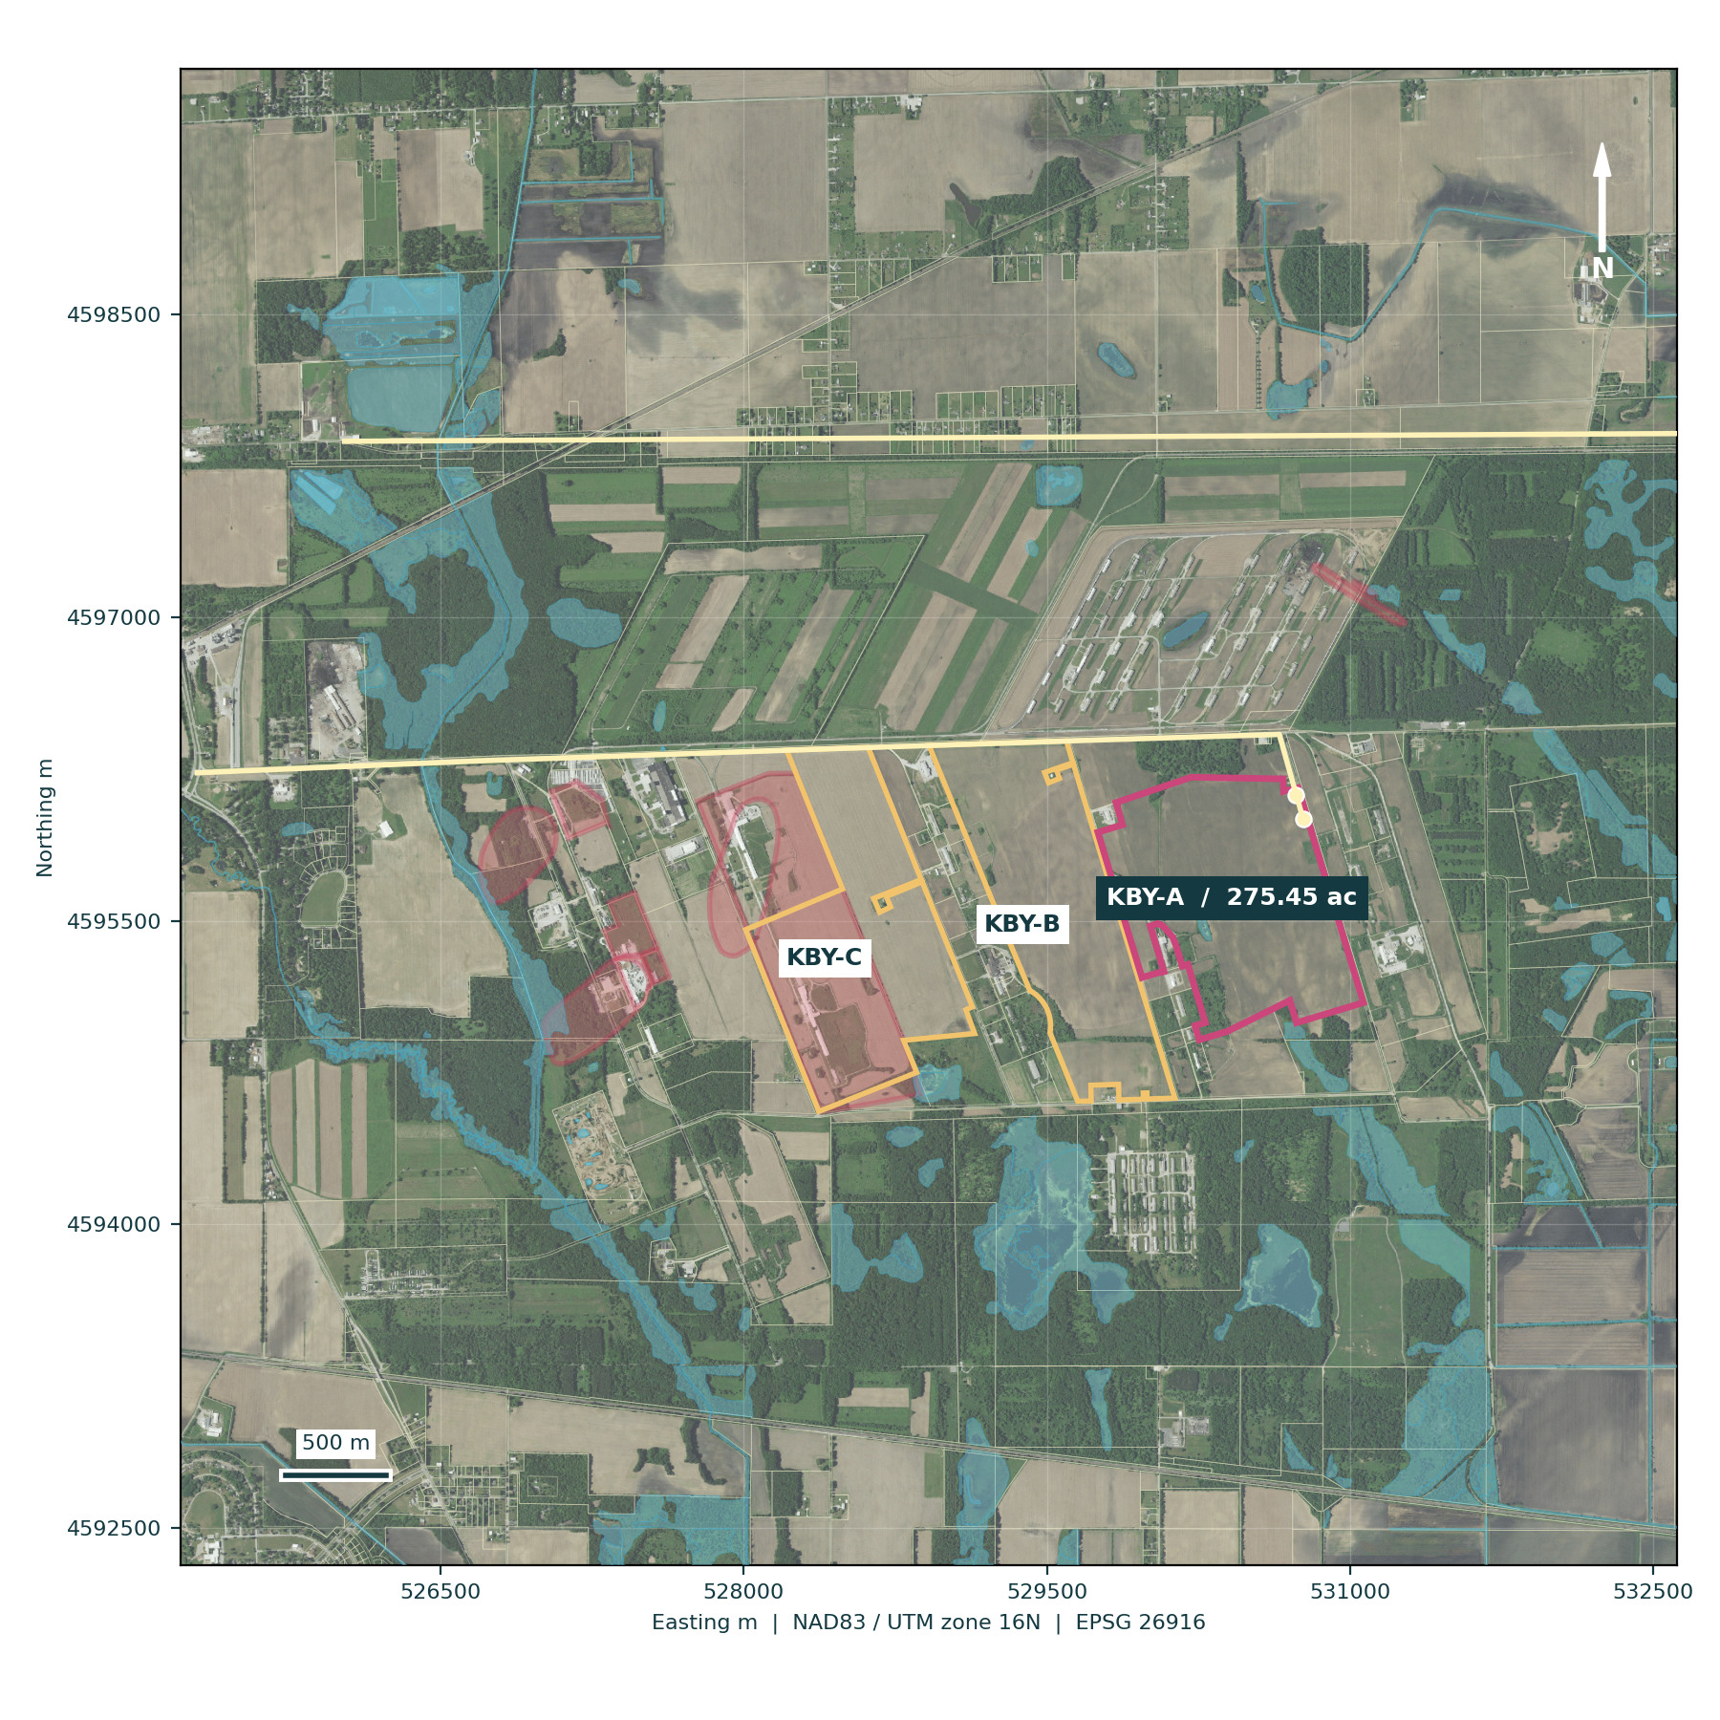
The location. Kingsbury offers an established industrial setting in LaPorte County, access toward Hupp Road and a regional freight network. The mapped KBY-A reference campus is 275.45 gross GIS acres on S 5th Line Road. The record has no verified street number.
The customer opportunity. Focus on industrial fleets, ports, transit and critical-power applications where frequent cycling and short charging windows can justify a premium. Proposed customers have not signed supply commitments.
The decision. Release up to $35 million in controlled work packages for land diligence, pre-FEED, product testing, pilot design, utility studies and customer development. This is included in cumulative funding, not a second authorization on top.
County-origin parcel geometry and acquired regional imagery. The original 41.5090, -86.6310 coordinate remains a search reference, not a gate.
Reference selection is conditional on title, contamination, wetlands, utility availability, access and commercial qualification.

KINGSBURY INDIANA / DEVELOPMENT PROPOSAL / 03

One portfolio with distinct operating roles
Coordinate mineral supply and manufacturing without inventing ownership or a partnership.

Milieu Minerals
Leads the portfolio development proposition, mineral-supply strategy, commercial coordination and investment-stage decisions.
Kingsbury is geographically and commercially separate from the Silver Peak and Petersburg uranium proposals. Neither uranium project is assumed to supply lithium or titanium to this campus.
Public project label: Kingsbury, Indiana. Internal project key: kingsbury-lto.

Milieu Power
Retains the source plan attribution for the LTO battery and energy-storage program. Leads powder, cell, module, pack and customer qualification.
Building identity: Milieu Power on pilot and manufacturing facilities; Milieu Minerals on the public administration frontage, with Milieu Power program attribution.
These are proposed functional roles. A legal ownership structure, subsidiary or executed joint venture has not been established by this proposal.

Milieu GeoTrace
Provides mapping, prospectivity, sensors, data and integration services. Connects site evidence, environmental monitoring, geometry, quantities and operational traceability.
Laboratory and data spaces carry Milieu GeoTrace attribution within the campus sign schedule.
The spatial register is the common reference for drawings, the Blender scene, web selection and quantity takeoff. No radiometric response is represented as lithium or titanium concentration.
Co-branding schedule KBY-01 applies to the plan, building signs, gallery and website. Corporate and contractual authority must be documented before agreements are executed.

KINGSBURY INDIANA / DEVELOPMENT PROPOSAL / 04

Customers buy a tested duty cycle
LTO is attractive only where its whole-system value exceeds its cost and energy-density tradeoff.
Commercial LTO products demonstrate that the chemistry category can serve demanding power and cycling applications [D10]. A Milieu product must independently prove life, rate, temperature, safety and warranty performance. One initial cell form factor and one qualified cathode pairing limit the first qualification burden.
Priority | Customer problem | Initial offer | Evidence before scale
1 | Port and industrial fleets need fast turnaround | Rugged modules and serviceable packs | Paid trial using representative load and charging data
1 | Transit depots need predictable availability | Application-specific traction pack | Customer safety acceptance and field duty-cycle validation
1 | UPS and critical power need reliable ride-through | Rack or cabinet system | Power, thermal and propagation testing with integrator
2 | Rail and defense require tailored qualification | Qualified module platform | Program nomination, sourcing and support obligations
Defer | Long-range passenger vehicles prioritize energy density | No launch product | Revisit only after a separate commercial case
The commercial gate remains at least 1.2 GWh/year of creditworthy binding Phase I demand plus a qualified pipeline. The current demand assumptions are planning inputs. No market-share estimate substitutes for signed customer evidence.
Source: Toshiba commercial category context [D10]; customer priorities and advancement thresholds are Milieu planning assumptions.

KINGSBURY INDIANA / DEVELOPMENT PROPOSAL / 05

Compare real campus configurations
A reference parcel is selected for coordinated design, with two actual alternatives kept in view.
Configuration | Spatial basis | Merit | Selection constraint
KBY-A selected | 46-15-03-300-009.000-066; 275.45 gross GIS acres | Single tract; 943 m from mapped EPA boundary | 1.04 acres mapped NWI wetland; no mapped SFHA overlap; title and utilities unconfirmed
KBY-B fallback | 46-15-04-400-017.000-066; 251.90 gross GIS acres | 3rd to 4th Line Road; 662 m from mapped EPA boundary | No mapped NWI or SFHA overlap in retrieved layers; legacy use, ownership and access unresolved
KBY-C disfavored | 46-15-04-300-002.000-066 and 46-15-04-300-004.000-066; 265.63 acres | 2nd to 3rd Line Road assemblage | 122.32 acres overlaps EPA comprehensive site area; direct remedy and land-control interfaces
KBY-A has the largest gross area and greater mapped separation from Fisher-Calo than KBY-B. That supports its conditional selection as the design reference. County owner names and legal descriptions were not published in the acquired service; title, seller and current zoning remain outstanding for all three configurations.
The source 260-acre program is rebased to the retrieved parcel. After only NWI and a provisional 30 m avoidance envelope, 271.50 acres remain as a screen, not verified buildable area. The optional 100-acre expansion is excluded. A 2014 M-2 map reproduced by EPA does not replace current written zoning confirmation.
County-origin IGIO parcel service retrieved 17 September 2026; county load 12 August 2025. Marketing acreage and M-2 claims are not title, a zoning determination or service commitments.

KINGSBURY INDIANA / DEVELOPMENT PROPOSAL / 06

A mapped campus with a controlled boundary
Use the parcel as the design frame and confirm each legal right before committing to it.
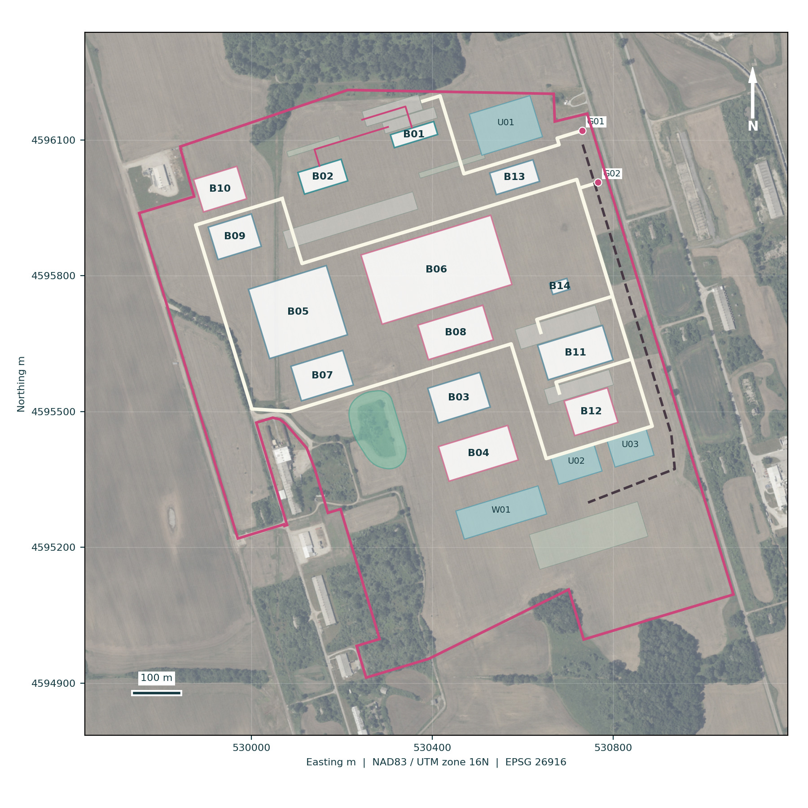
KBY-A reference campus. County-origin parcel 46-15-03-300-009.000-066, S 5th Line Road, La Porte, Indiana 46350. Record centroid 41.51157874, -86.63550749. Gross GIS area 275.45 acres.
Access. Proposed G01 visitor gate: 41.516135, -86.631704. Proposed G02 logistics and emergency gate: 41.515100, -86.631289. A traced route from G02 toward US 35/US 6 via 5th Line and Hupp roads is 5.79 km, with about 50 m positional precision; road rights and truck suitability are unverified.
Land rights. Seek an assignable option with environmental, survey, utility and access conditions. Title, beneficial owner, legal description, road rights, off-site easements and future expansion rights remain unconfirmed.
Evidence limit. Parcel mapping has cadastral context but is not an ALTA survey. Existing structures and land uses require field inventory and a disposition plan before layout freeze.
Master plan from the authoritative feature register, over acquired imagery. Detailed dimensions and schedules are in the A3 atlas.
No verified numbered street address is invented. Boundary positions and gate locations must be replaced or confirmed by licensed survey and engineering.

KINGSBURY INDIANA / DEVELOPMENT PROPOSAL / 07

Environmental evidence governs site selection
Fisher-Calo and groundwater controls require affirmative diligence, including outside mapped boundaries.
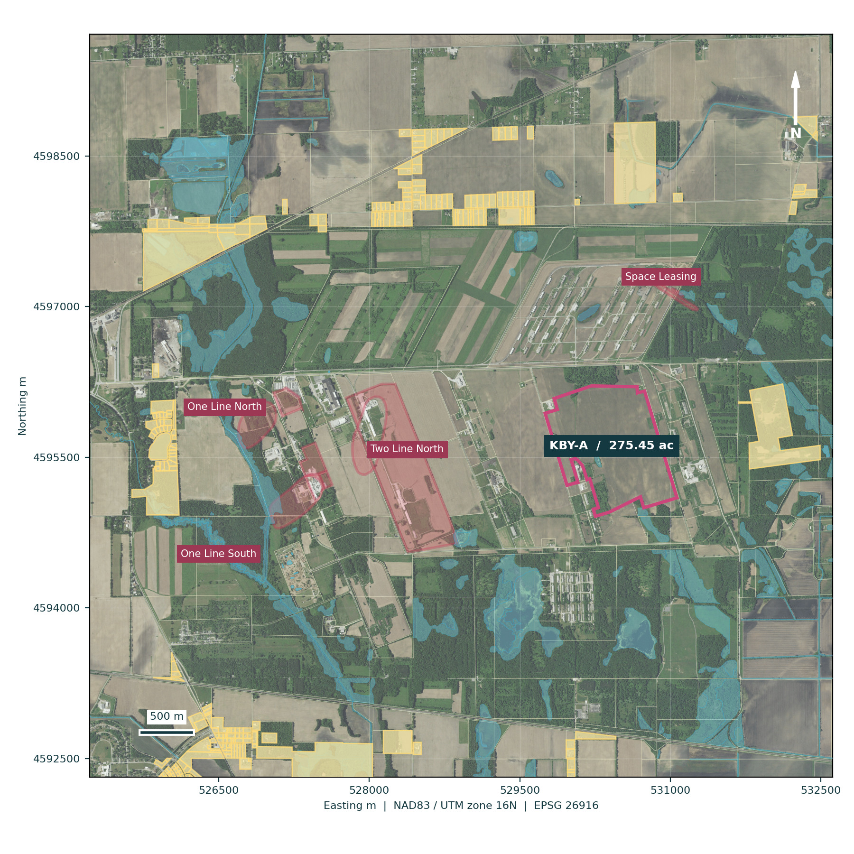
Current record. EPA's 22 August 2025 five-year review describes one sitewide operable unit and four groundwater plumes. Its short-term protective determination is not unrestricted-use clearance. Groundwater extraction and treatment, vapor work and institutional controls remain relevant.
Open issues. The review identifies vapor monitoring, control finalization and PFAS record-review actions with 2028 milestones, plus a 2030 groundwater-remedy evaluation. The selected parcel is approximately 943 m from the mapped EPA site area; that separation does not establish clean conditions.
Selection gate. Obtain title instruments, remedy access rights, well results and vapor data. Complete a Phase I ESA, targeted Phase II and agency consultation before an unconditional land decision.
Receptors. Nearest residential-class parcel: 772 m, occupancy unverified; improved-residential example: 1,747 m. Official school-point screens: Kingsford Heights Elementary 5.41 km; Kingsbury Elementary 7.05 km. School grounds, childcare and occupied-building inventories remain unverified.
Published environmental layers, with source-specific interpretation. Unmapped plume or vapor conditions remain an investigation need.
Sources SITE-06 to SITE-09 and SITE-12/13. County well ordinance 2015-06 applies countywide. No KBY-A groundwater, soil or vapor samples were acquired.

KINGSBURY INDIANA / DEVELOPMENT PROPOSAL / 08

Terrain and water are design constraints
The landscape model informs a screen; a civil design must establish finished levels and drainage.
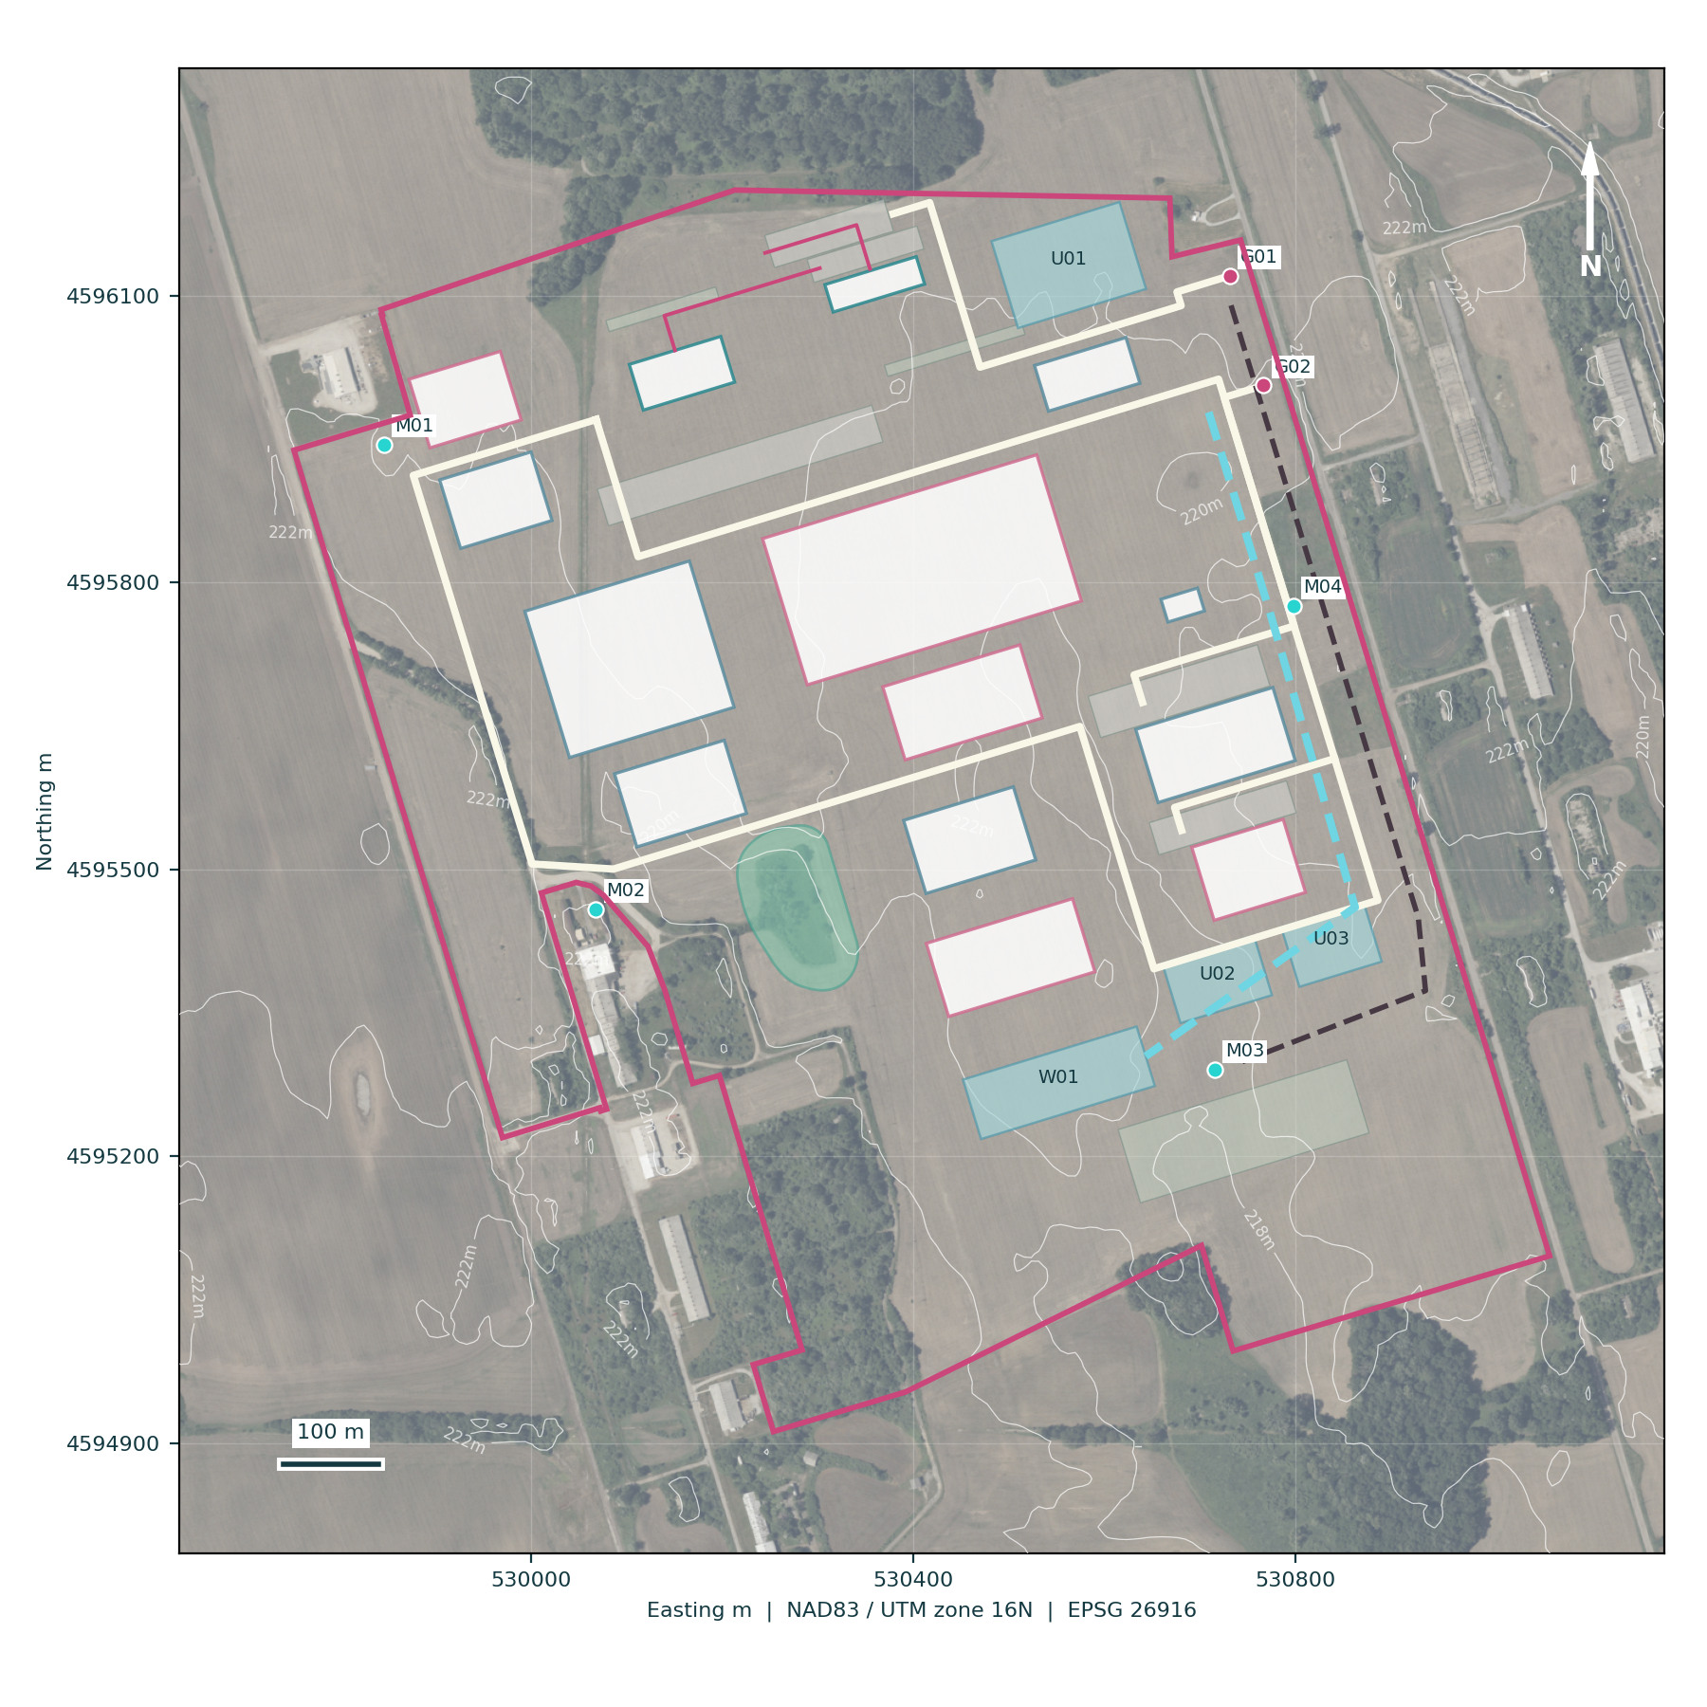
Acquired terrain. USGS 3DEP 1 m elevation derived from 2017 LiDAR, published 4 July 2021, ranges from 216.77 to 224.61 m NAVD88 across the parcel. Median slope is 0.96 degrees; the 95th percentile is 3.35 degrees. These are raster screens, not surveyed grades.
Wetlands. Retrieved NWI polygons identify 1.04 acres inside the parcel. The model avoids that feature plus a provisional 30 m envelope. Field delineation, soils, hydrology and agency review determine actual limits and any permit requirements.
Drainage. Concept basins, swales and containment are spatial reservations. Storage volume, outlet ownership, infiltration suitability, groundwater separation and design storms are not yet engineered.
Flood and ground. The retrieved Indiana DNR Best Available layer places the selected parcel in Zone X; the nearest mapped special flood-hazard area is about 112 m away. Confirm a current FEMA determination, survey and drainage design. Geotechnical bearing, infiltration and groundwater levels remain untested.
Terrain and drainage concept share the site register. Preliminary floor levels are model assumptions, not construction benchmarks.
No earthwork balance, flood clearance or stormwater permit is inferred from visualization. Off-site discharge and utility easements remain conditional.

KINGSBURY INDIANA / DEVELOPMENT PROPOSAL / 09

Grow the campus through four release gates
Qualification precedes commercial capacity and repeat construction follows demonstrated demand.
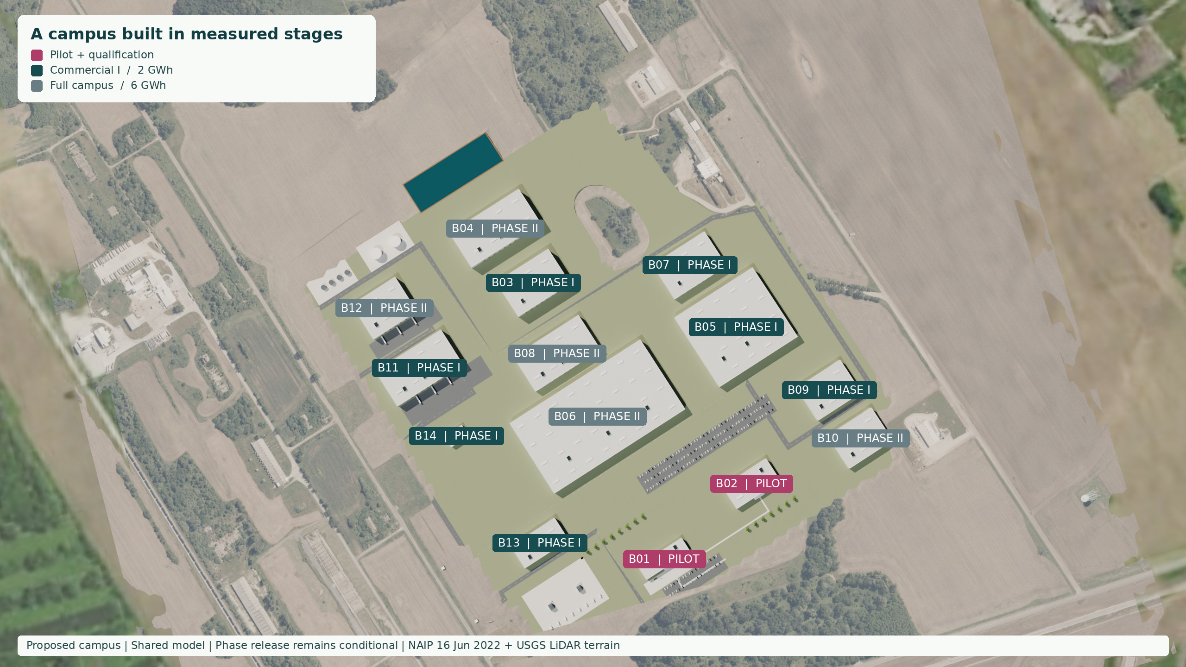
0 Diligence establishes the site and process basis. 1 Pilot installs a 50 MWh/year qualification line. 2 Commercial I adds 2 GWh/year cell capacity and 6,000 t/year LTO powder nameplate. 3 Full campus expands to 6 GWh/year cells and 18,000 t/year powder only after demand, utilities and qualification gates.
Four-phase schedule is the common convention used by the geometry, workbook, drawings and website. Projected building IDs and phase labels identify proposed scope.
Capacity denotes design nameplate. Qualified throughput and shipments are modeled separately. Full-build scope is not authorized by the first $35 million tranche.

KINGSBURY INDIANA / DEVELOPMENT PROPOSAL / 10

A pilot that earns the right to scale
The first physical campus supports materials learning, full-cell qualification and customer acceptance.
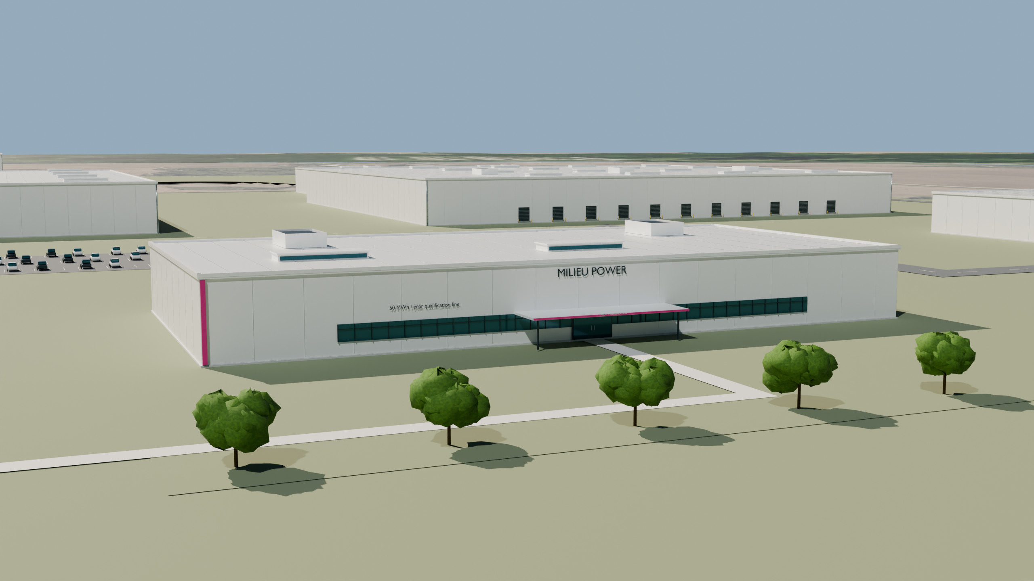
50 MWh/year design basis. Pilot and R&D space includes powder and cell development, metrology, cycling, controlled assembly, customer samples and safe test handling. Purchased qualified feed can support early work before commercial synthesis is built.
Qualification sequence. Verify repeat powder lots, select the cathode and electrolyte pairing, build A/B/C samples, close failure modes and freeze the production-intent design.
Release evidence. Customer acceptance, independent safety testing, reproducible rate runs and a process capability record must support expansion. A 90-day representative run is the proposed operating gate.
Budget discipline. The $35 million diligence tranche funds pilot design and reservations. It does not claim to buy a completed 50 MWh facility; installed pilot capital is separately priced in the model.
V03 registered camera. Bright white architecture, tinted glazing and restrained Milieu pink details are generated from the same scene as every final view.
A sample line is not automatically a production-qualified line. Equipment guarantees, throughput and quality must be supported by supplier proposals and testing.

KINGSBURY INDIANA / DEVELOPMENT PROPOSAL / 11

From qualified feed to finished systems
Keep each chemical and product stage distinct, and carry quality records through every transformation.

Materials to LTO
Receive qualified lithium carbonate and titanium dioxide under lot quarantine. Brine and mineral concentrate are upstream products, not direct cell inputs.
Meter and wet mill the feed, spray dry, calcine, classify and finish the LTO powder. Control stoichiometry, phase purity, particle size, surface area, moisture and residual alkali.
Planning reaction: 2 Li2CO3 + 5 TiO2 yields Li4Ti5O12 + 2 CO2. Theoretical coefficients per tonne LTO are 0.322 t carbonate, 0.870 t TiO2 and 0.192 t process CO2.

Powder to full cells
LTO is the anode material. Complete cells also require a qualified cathode, electrolyte, separator, current collectors and housing.
Mix, coat, dry, calender and slit electrodes; assemble and fill under controlled dry conditions. Follow with formation, aging, grading and traceability.
An NMC or LMO family pairing remains a development baseline. Cathode selection, voltage, energy density, cycle life and fast-charge targets remain conditional on full-cell testing.

Cells to systems
Build modules and packs with busbars, cooling, isolation, BMS, contactors and serviceable enclosures. Perform end-of-line electrical, thermal and functional tests.
Sell standalone cells, packs or finished systems according to the external product mix. Internally transferred powder and cells are not counted again as external revenue.
The initial on-site scrap role is safe discharge, segregation and pre-processing. Chemical recycling and TiO2 conversion remain separate, gated scopes.
Stoichiometric coefficients are rounded engineering anchors. The workbook applies synthesis yield to feed once and defines cell-material procurement intensity explicitly.

KINGSBURY INDIANA / DEVELOPMENT PROPOSAL / 12

Buildings are linked to quantities and cost
Permanent feature IDs connect the design schedule to the investment model.
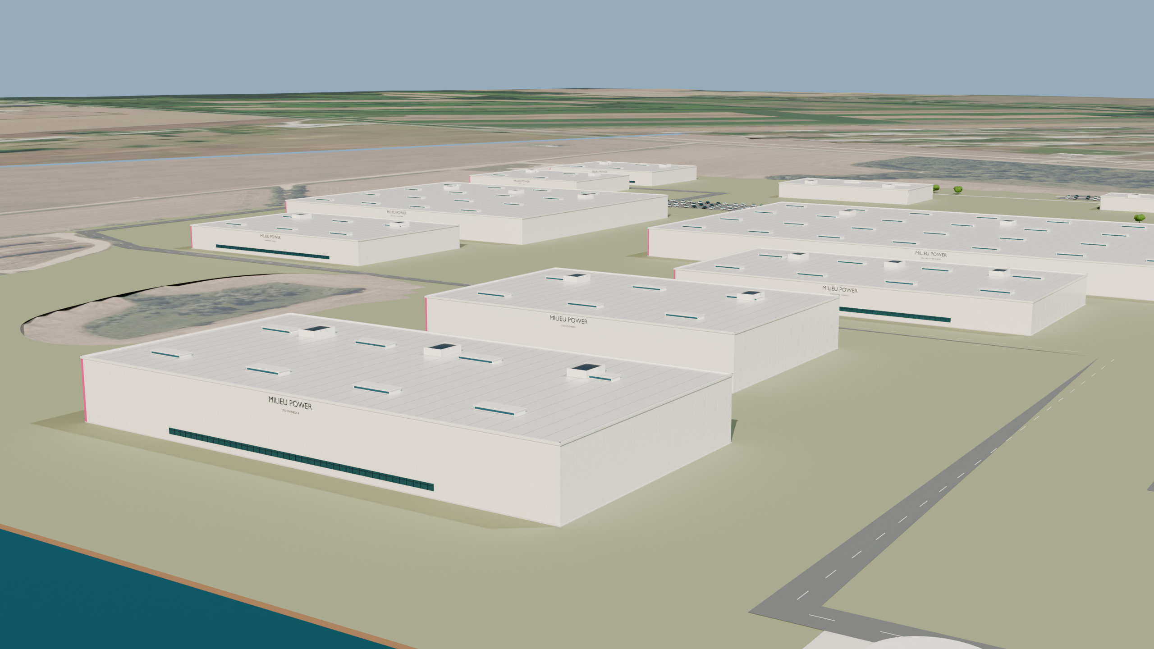
169,800 m2 building footprint. Fourteen facilities provide 172,800 m2 gross floor area, including the two-floor administration and GeoTrace laboratory. Land reservations, footprints and GFA are kept separate.
Permanent IDs. B01 and B02 establish the pilot frontage. B03/B04 synthesize LTO; B05/B06 house cell production; B07/B08 formation and aging; B09/B10 module and pack work; B11/B12 warehouses; B13 utilities; B14 scrap and quarantine.
Process design. Controlled rooms, equipment and service allowances are separately priced. Space is provided for process requirements without claiming a completed engineering layout.
Release control. The A3 schedule records each footprint, GFA, height and phase. The equipment register governs capacity, and the cost ledger covers each feature or shared work package once.
V04 registered manufacturing camera. Buildings, roof forms, roads, materials and landscape remain consistent with the master scene.
The A3 building schedule and Geometry_Register are controlling for dimensions, heights, orientation and floor areas. Land-use reservations, footprints and GFA are not interchangeable.

KINGSBURY INDIANA / DEVELOPMENT PROPOSAL / 13

Visitors and heavy vehicles have separate routes
A welcoming front door can coexist with controlled production and safe logistics.
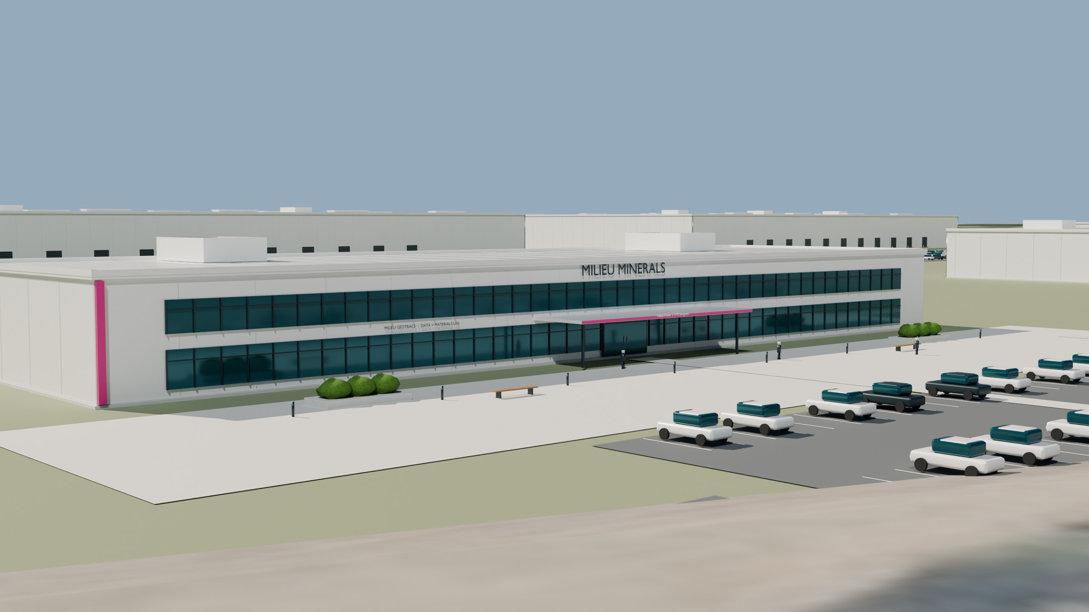
Public frontage. Administration, training and the pilot welcome area face a clear arrival sequence with short pedestrian connections. Visitors remain outside controlled production unless escorted.
Production access. Truck inspection, material receipt and loading serve the industrial side. Hazardous materials, damaged batteries and returns follow controlled routes with isolation and response access.
Rail. A proposed rail corridor and transload reservation are included only as a conditional connection. Existing district rail availability does not establish a usable siding, turnout, tariff or easement for this parcel.
Emergency access. G02 also serves proposed emergency response through the production loop, separate from the visitor gate G01. Fire-apparatus turning, clearance, hydrant coverage and the need for another independent emergency access must be resolved with the fire authority.
V02 registered entrance camera. The sign hierarchy matches the portfolio and Milieu Power program attribution.
Traffic, emergency and rail approvals remain release conditions. A proposed route is not a right of access.

KINGSBURY INDIANA / DEVELOPMENT PROPOSAL / 14

A logistics campus with clear operating boundaries
Material quality, safe handling and access rights matter as much as the route to the gate.
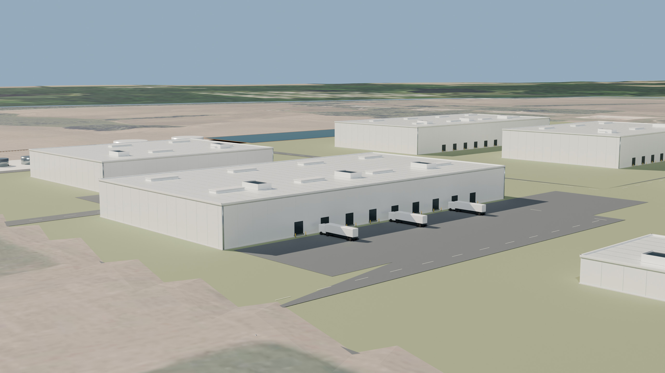
Inbound. Quarantine lithium carbonate, TiO2 and other components until lot acceptance. Covered receipt and segregated storage reduce contamination and mix-up risk.
Outbound. Release tested cells, modules and systems against serialized records. The reference mix is 5.1 GWh/year external battery shipments, plus 2,500 t/year of external LTO powder.
Returns and scrap. Isolate damaged products, verify state of charge and route them to safe discharge and approved off-site processing. Finished goods do not share uncontrolled space with returns.
Logistics economics. The current freight model uses road movements. Rail is a conditional reservation with no base-case volume credit; access, turnouts, easements and carrier service remain uncommitted.
V05 registered logistics camera from the same controlled Blender scene. Loading aprons and roads match the feature register.
Final operating plans require hazard analysis, trained personnel, emergency coordination and transport-compliant packaging.

KINGSBURY INDIANA / DEVELOPMENT PROPOSAL / 15

Utilities are sized from the operating case
Replace inherited peak targets with a transparent energy and water calculation.
The source plan assumed 90 MW for the first commercial stage and 150 MW for full build. The revised reference calculation is approximately 381 GWh/year, 43.5 MW average and 79.1 MW modeled peak at a 0.55 load factor, with a 90 MW full-campus design reservation. Commercial I uses a 40 MW reservation pending engineering.
Service | Reference planning basis | What must be committed
Electricity | 55 kWh per throughput kWh of cells; 4 MWh/t finished powder; 25 GWh fixed annual campus use | Utility load and fault studies, supply tariff, connection date, reliability and upgrade responsibility
Connection voltage | 138 kV retained only as a study concept | Utility determines voltage, substation, route and redundancy; no capacity letter acquired
Water | 0.247 MGD fresh-water planning demand after 70% reuse target | Firm source capacity, quality, fire flow, seasonal limits and lawful withdrawal rights
Wastewater | 0.148 MGD modeled wastewater; segregated process, sanitary and storm systems | Sampling basis, discharge limits, receiving-system capacity and approvals
Truck and rail | 57 truck movements/day reference; 20 t payload; 300 shipping days; zero rail share | Traffic study, payload limits, carrier service, siding agreement and hazardous-goods route
The EIA June 2026 Indiana industrial average of $90/MWh is a benchmark [D12], not a site tariff. The cost model tests $120/MWh downside and $75/MWh upside. No utility marketing statement is treated as a written service commitment.
All utility values are engineering assumptions. Rate, simultaneous demand, recovery systems and process duty cycle require supplier and utility confirmation.

KINGSBURY INDIANA / DEVELOPMENT PROPOSAL / 16

Domestic supply is a geographic network
Arkansas and Tennessee are regional supply screens, separated from the Indiana campus by real distances.
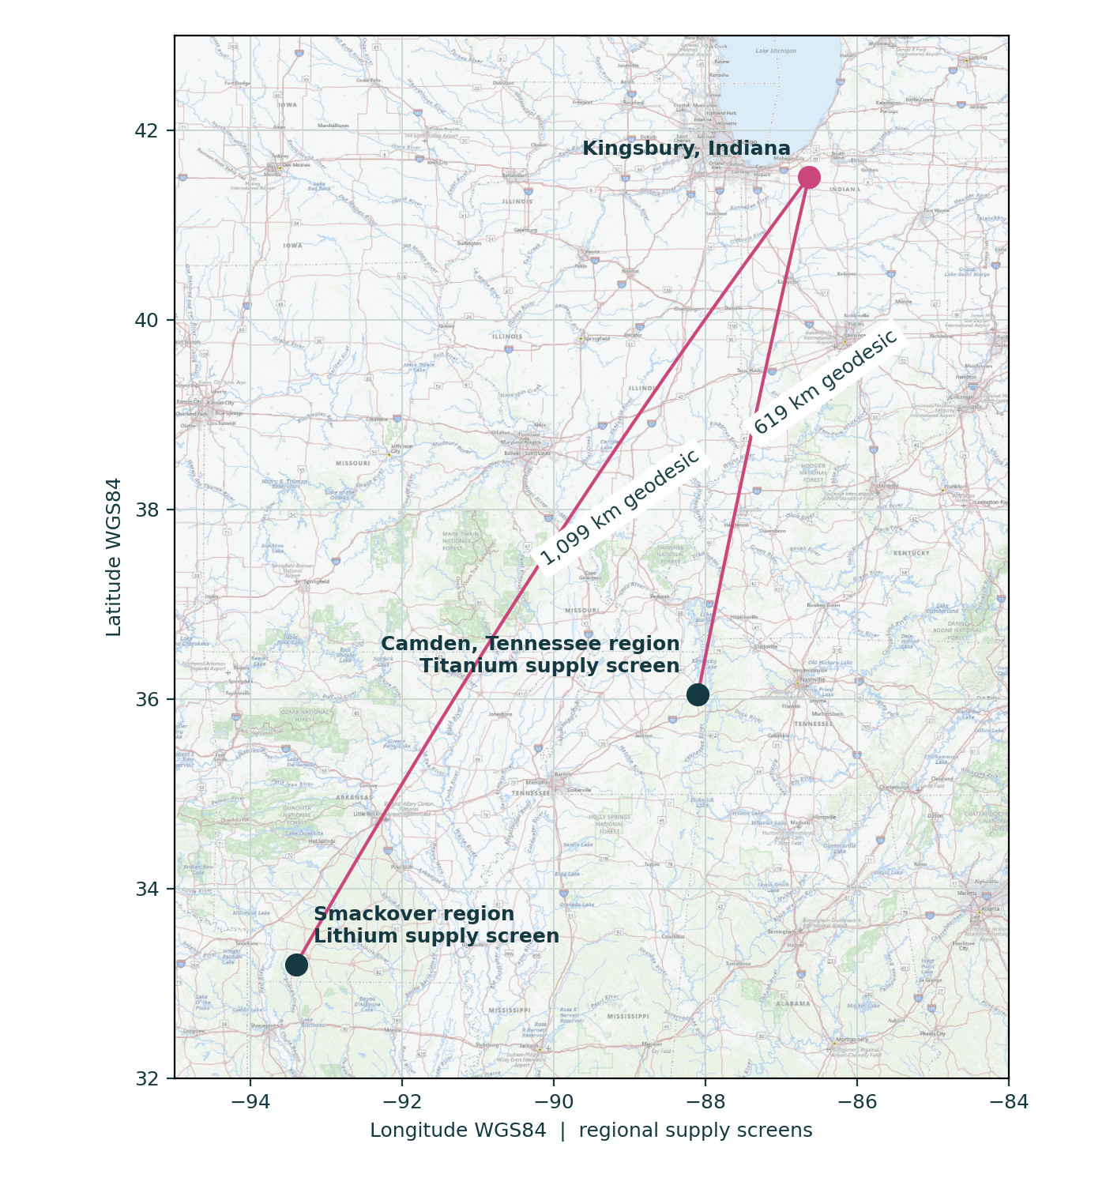
Lithium. Seek battery-quality lithium carbonate through Smackover-linked suppliers. The South West Arkansas DFS is a published third-party benchmark, not Milieu-controlled capacity or a supply commitment [D08].
Titanium. The Titan project near Camden, Tennessee is a mineral-concentrate benchmark. A separate chemical conversion route must deliver qualified TiO2 before it can enter LTO synthesis [D09].
Contract sequence. Prefer supply/offtake and toll-processing agreements. Add milestone-based prepayment or minority investment only where it improves security, quality and economics.
Ownership option. On the historical basis, replacing the full $250 million participation allowance with $1.45 billion DLE and $381.3 million mineral-sands benchmarks gives $4.2113 billion, not $4.4613 billion. This is not an acquisition valuation or a revised ownership-case forecast.
Regional supplier screens are mapped at their true location. Connecting lines are geodesic separation, not surveyed facilities or road freight routes.
No Indiana lithium or titanium mine is assumed. Silver Peak and Petersburg are separate uranium proposals and are not feed sources for Kingsbury.

KINGSBURY INDIANA / DEVELOPMENT PROPOSAL / 17

Qualification is the missing link in the supply chain
A domestic source label alone does not establish a usable battery feed.
Product | Acceptance and conversion test | Commercial protection
Lithium-bearing brine | Resource, rights, DLE recovery, impurities and reinjection are upstream responsibilities | No brine tonnes counted as campus carbonate supply
Lithium carbonate | Assay, sodium, calcium, magnesium, boron, chloride, sulfate, moisture and particle size | Approved lot specification, samples, audit and reject or replace terms
Titanium mineral concentrate | Mineralogy, impurity suite, recoverability and conversion route | Separate mine offtake from conversion toll and purified-product warranty
Purified TiO2 | Chemistry, crystal form, particle size, surface area, trace metals and electrochemical correlation | Dual source qualification, no change without notice and revalidation
LTO powder | Phase purity, residual alkali, morphology, carbon coating, moisture and rate behavior | Retained samples, lot genealogy, dispute laboratory and cell correlation
Full cell and pack | Use-case safety, power, temperature, aging, controls and warranty envelope | Paid qualification, binding nominations, throughput warranty and telemetry rights
At reference output, procurement must support finished powder demand of 14,740 t/year. The model applies a 95% synthesis yield to the feed calculation. Long-term agreements should have stepped volume, qualified backups, price formulas, milestone security and contingency inventory.
No supplier quotation, executed offtake, qualified lot or product-performance guarantee has been supplied. These requirements are proposed contracting and test gates.

KINGSBURY INDIANA / DEVELOPMENT PROPOSAL / 18

Acquire evidence at the scale of the question
The data package separates completed spatial work from future acquisition and testing.
Evidence | Completed use | Limit and next action
Aerial imagery | Acquired regional image and service metadata provide land-cover and access context | Mosaic vintage and resolution vary; obtain licensed survey-grade site orthophoto for design
Elevation and LiDAR | Native 1 m 3DEP DEM and metadata support terrain screening | Raster terrain is not a survey; acquire benchmarks and verify vertical datum
Parcel and environmental GIS | County-origin parcels, NWI and published EPA or IDEM layers overlay the campus | Boundary, ownership, legal controls and wetland jurisdiction require authoritative confirmation
Sentinel and Landsat | No calibrated campus spectral mineral analysis is claimed | Acquire only where seasonal land cover or change detection materially helps; retain dates and native resolution
Geology and boreholes | Regional reconnaissance context is reviewed | Site borings, geotechnics, groundwater levels and lab assays remain future work
Geophysical and radiometric data | No lithium or titanium assay is inferred | Any future survey needs calibration, target model, ground truth and a measured detection limit
The optional Indiana exploration program remains a separate $8 million to $12 million decision. USGS reconnaissance of unconventional critical minerals does not establish a Kingsbury feed reserve [D11]. No value, feed security or revenue from that exploration is included in the manufacturing case.
Analytical files retain their source dates, CRS, resolution and rights. Unavailable or inappropriate data are documented as future work, not portrayed as completed analysis.

KINGSBURY INDIANA / DEVELOPMENT PROPOSAL / 19

Capital follows the actual facility scope
Measured model quantities and explicit planning rates replace the inherited lump-sum headline.
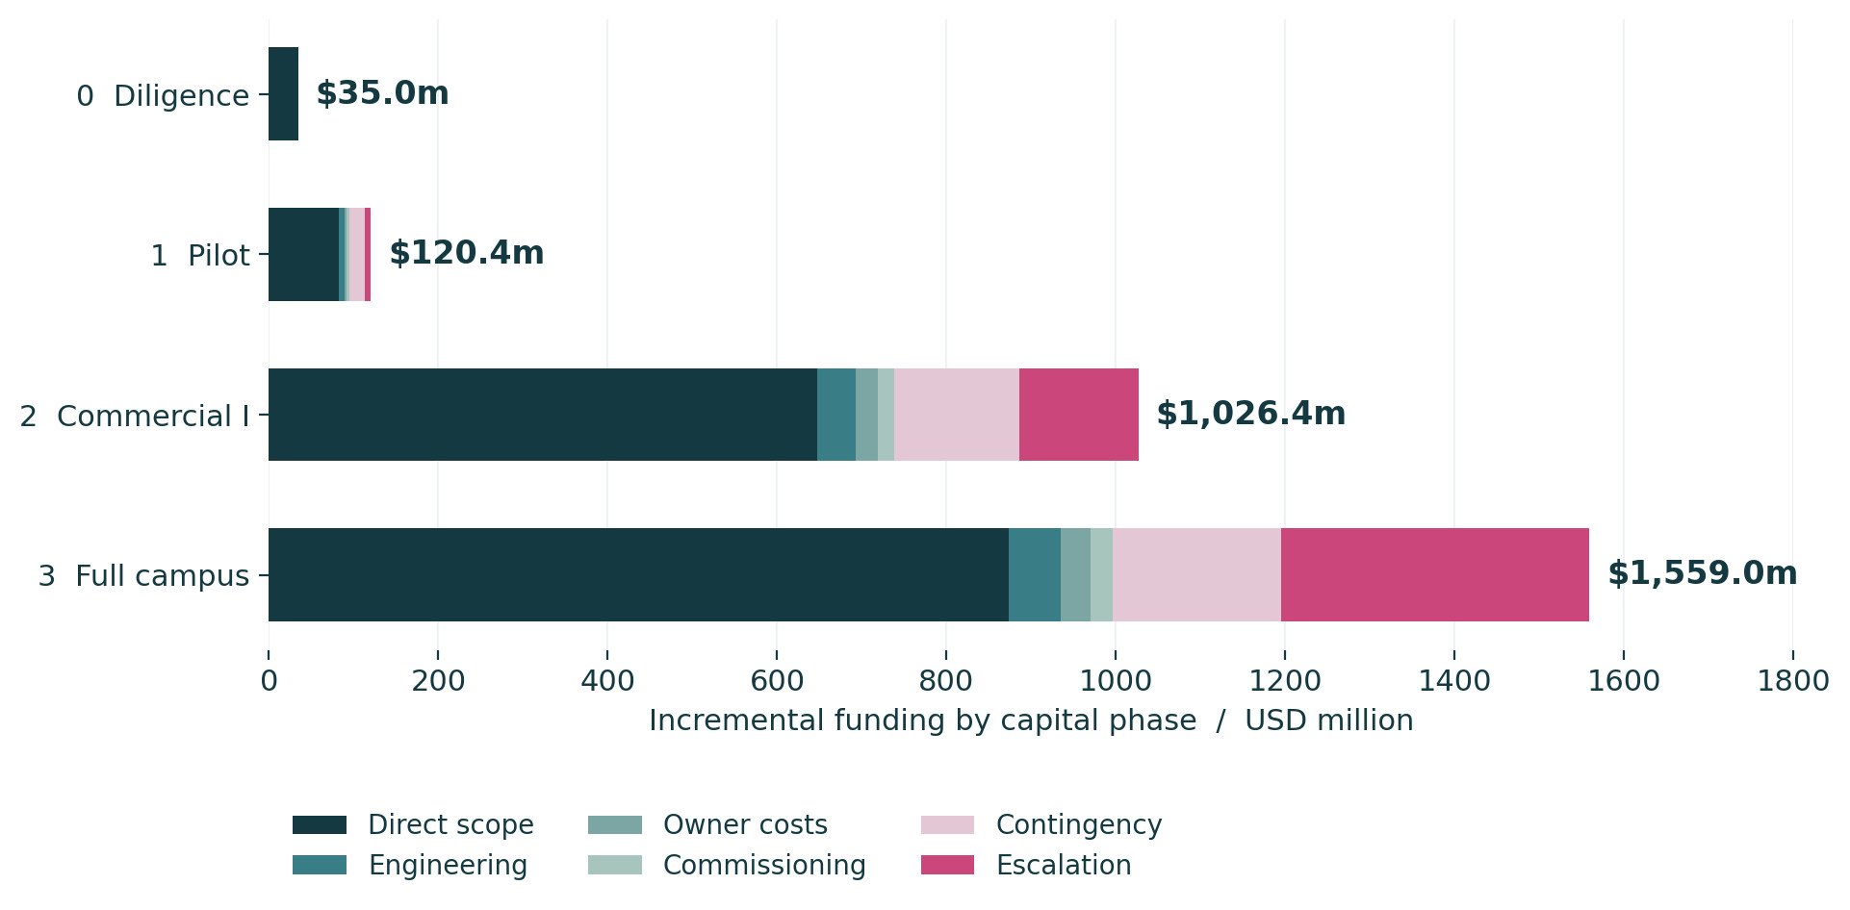
The revised capital program is $2.741 billion, including the $35 million early authorization once. Manufacturing capital is $2.713 billion: $28 million of early development expense is outside manufacturing, while the $7 million creditable pilot reservation offsets later equipment spending.
The inherited $2.20 billion manufacturing estimate is retained as history. Quantities now determine scope, with engineering, owner costs, commissioning, contingency and escalation separate. Each major feature has a cost treatment; optional upstream ownership, Indiana exploration and unpriced off-site rights remain outside the base.
2026 planning basis with escalation shown separately. Quantity and cost ledgers reconcile to the authoritative geometry register.
The estimate is not a supplier quotation or an investment-grade feasibility estimate. Unpriced optional scope is excluded and separately identified.

KINGSBURY INDIANA / DEVELOPMENT PROPOSAL / 20

Fund the zero-incentive case first
The financing gap must be resolved with committed capital or a smaller project.
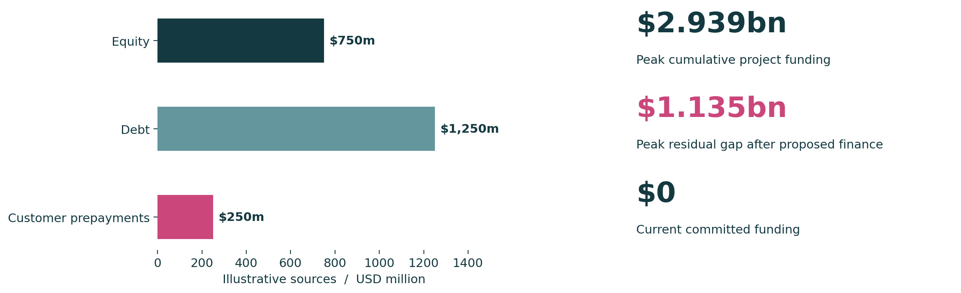
Peak cumulative project funding is $2.939 billion in the reference annual cash forecast, including the $250 million upstream participation allowance and operating ramp. The proposed $2.25 billion private stack leaves a $1.135 billion peak residual financing gap after modeled debt service and customer-prepayment repayment. This is a time-based liquidity gap, not simply project funding less sources.
Current committed funding is zero. The inherited $2.63 billion uses included $380 million of unsupported state/local support and federal bridge funding; removing those sources left a $380 million historical gap. Both assistance lines now contribute zero. The revised scope and ramp govern the new funding requirement.
Conditional assistance is shown outside base funding. A source label or government program is not an award, a financing commitment or cash.
No securities offering, credit approval or term sheet is inferred. Construction release requires a financeable completion plan and downside liquidity.

KINGSBURY INDIANA / DEVELOPMENT PROPOSAL / 21

Revenue is external sales after explicit adjustments
The operating case has no double-counted powder or cells.
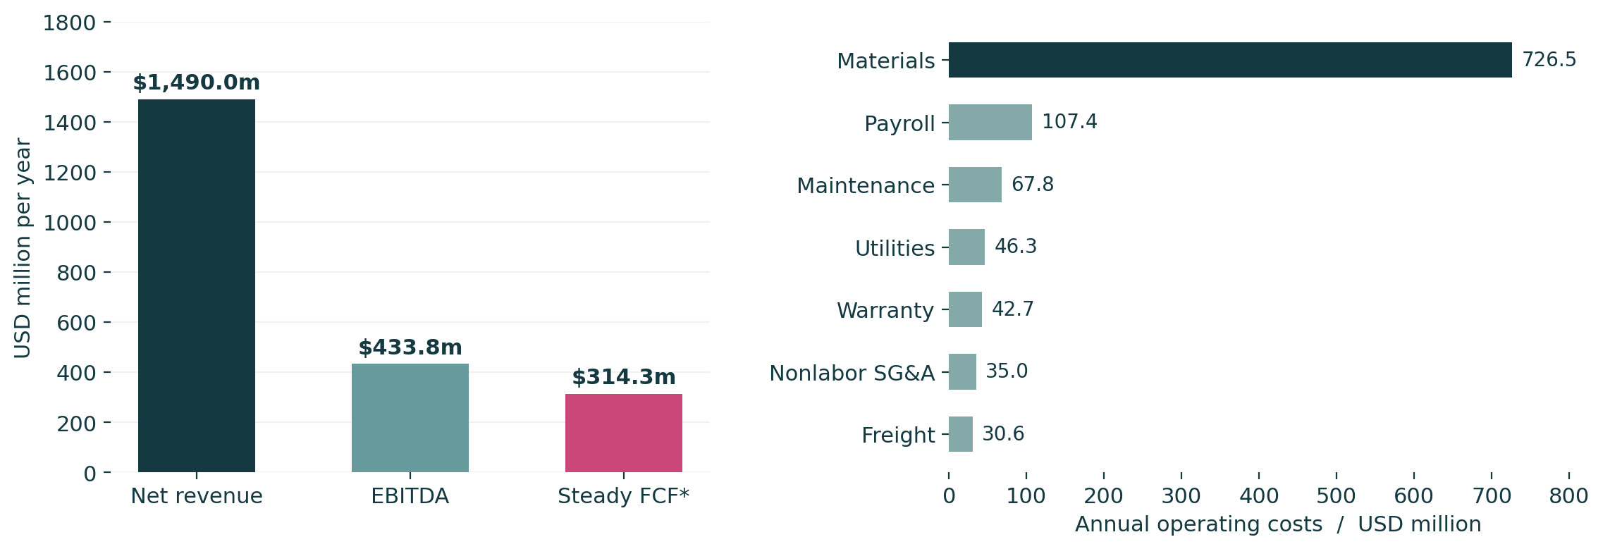
The reference case produces $1,490 million net revenue, $433.8 million EBITDA and $314.3 million steady unlevered free cash flow. Free cash flow includes modeled cash tax, sustaining capital and a closure reserve, before growth capital and working-capital change. Steady working capital is $334.5 million.
Gross sales of $1,627.5 million reduce by proposed $78 million negotiated discounts, $39 million rebates and $20.5 million acceptance credits. These allocations are new assumptions that explain the inherited net figure. They require contract evidence; warranty expense is separate. The full payroll is counted once.
At reference shipment mix, 2.0 GWh cells + 2.5 GWh packs + 0.6 GWh systems = 5.1 GWh total external battery shipments.
Annual cash-flow assumptions include a 25% illustrative tax rate, 15-year straight-line depreciation, 2% sustaining capital, $2 million annual closure reserve and illustrative 8% debt. No investment return is asserted.

KINGSBURY INDIANA / DEVELOPMENT PROPOSAL / 22

Material balance and staffing now reconcile
Resolve the inherited arithmetic before attaching capacity or employment claims to the project.
Item | Reconciled reference basis | Interpretation
Saleable battery output | 6.0 GWh x 90% throughput utilization x 94.444% qualified saleable yield = 5.1 GWh | Demand cap applies once; utilization and yield are separate
Internal LTO procurement | 5.1 million kWh x 2.4 kg/kWh = 12,240 t/year | Intensity includes reference cell losses; do not divide by cell yield again
Finished powder output | 12,240 internal + 2,500 external = 14,740 t/year | 81.89% of 18,000 t/year finished-powder nameplate
Powder capacity balance | 3,260 t/year unutilized design capacity | No unexplained inventory build or sale assumed for the remainder
Feed inputs | Finished demand / 95% synthesis yield x stoichiometric coefficients | Approximately 4,996 t/year Li2CO3 and 13,499 t/year TiO2
Full-campus organization | 1,105 FTE = 875 production and operating support + 230 SG&A and R&D | Corrects printed 1,050; no duplicated payroll in operating overhead
Loaded annual payroll is $107.355 million. Full staff rows are 520 production, 135 maintenance, 110 quality, 95 engineering/R&D, 55 EHS/security, 55 logistics, 35 digital, 45 commercial/service and 55 administration. Rates and ramp are explicit workbook assumptions.
Synthesis yield is applied only to feed for this balance. Downside yield changes affect procurement intensity through a documented ratio to the reference cell yield.

KINGSBURY INDIANA / DEVELOPMENT PROPOSAL / 23

Stress the case before expanding it
Demand, mix, quality and capital are interacting risks, not independent promises.
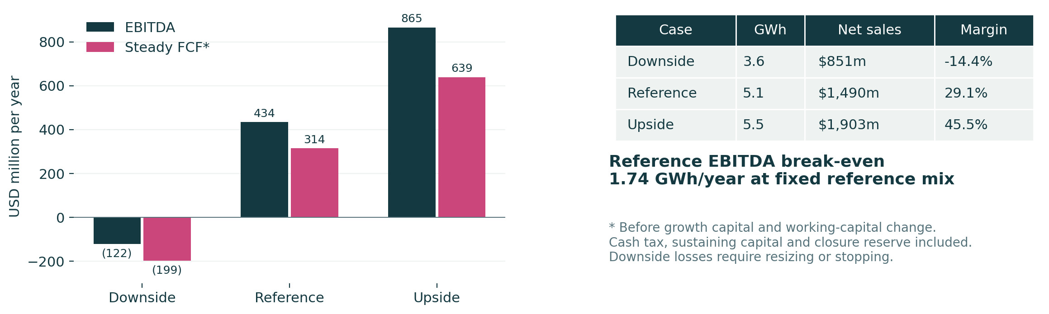
Downside, reference and upside cases vary selling prices, product mix, demand, throughput, yield, feedstock, electricity, freight, capital, delay and working-capital terms. Each case recalculates output, costs and cash requirements. Qualification delay adds funding pressure before receipts begin.
Advancement requires contracted demand, representative yield and independent capital validation. The workbook reports EBITDA break-even and a cash-flow basis separately; positive EBITDA alone does not establish an acceptable return or financeability.
Editable cases use the same model as the web scenario tool. Scenario outputs are illustrative, with no incentive income in any base operating case.
No resource or demand assumption is backfitted to a target IRR. Returns are meaningful only with explicit ramp, tax, financing and cash-flow assumptions.

KINGSBURY INDIANA / DEVELOPMENT PROPOSAL / 24

A schedule that leaves room for qualification
Commercial I sales are modeled from 2032, full capacity from 2036 and stabilization from 2037.
Period | Operating milestone | Evidence required to advance
2026 to 2027 | Diligence and pre-FEED; conditional site control; product and supplier screen | Site investigation, utility study, basis of design, paid customer development and updated estimate
2027 to 2029 | Pilot design, procurement, installation and qualification | Repeat lots, closed safety findings, customer sample acceptance and 90-day rate-run evidence
2029 to 2031 | Commercial I engineering, permits, financing and construction | Firm demand, qualified suppliers, permits, utility agreements and completion support
2032 to 2033 | 2 GWh/year nameplate ramp and customer release | Measured utilization, saleable yield, field reliability, cash conversion and covenant headroom
2034 to 2036 | Conditional expansion to 6 GWh/year and 18,000 t/year powder | Phase I operating evidence, contracted incremental demand, utility capacity and financed expansion
2037 onward | Reference stabilization | Validated product mix, steady staffing, maintenance, warranty and sustaining-capital provision
The inherited 2030 first-production and 2033 full-build targets are retired as uncommitted assumptions. The revised dates are a development sequence, not a guaranteed critical path. Utility upgrades, environmental diligence, qualification and financing can move each release.
Downside includes two additional years of qualification delay. Dates must be rebaselined after utility studies, site control, equipment bids and customer plans.

KINGSBURY INDIANA / DEVELOPMENT PROPOSAL / 25

Permitting and community are early workstreams
Assign accountable owners while the process design can still respond to constraints.
Responsibility | Authority or counterparty | Required work before release
Land use, access and building safety | LaPorte County and relevant road, building and fire authorities | Written use determination, site plan, road approvals, fire access and hazardous-material review
Air and emissions | IDEM Office of Air Quality [D06] | Inventory kilns, dryers, powder, solvent, combustion and emergency emissions; determine permit class
Water, wastewater and stormwater | IDEM, receiving utility, local drainage or MS4 authority [D07] | Water balance, pretreatment terms, construction erosion control, discharge and industrial coverage
Wetlands and waters | USACE and IDEM as applicable | Field delineation, jurisdictional determination and avoidance before permit applications
Materials, waste and transport | EPA, IDEM, OSHA, DOT and responding agencies | Waste profiles, chemical inventory, threshold reviews, safe return flow and qualified battery packaging
Community and workforce | Local institutions and proposed community advisory process | Publish traffic, water and safety information; training pathway and emergency-response drills
Water reuse, solvent capture, scrap diversion and workforce training remain measurable design targets. Do not present an ISO, IATF, UL or other certification as obtained. Independent tests and the authority having jurisdiction determine the applicable compliance path.
This is a responsibility map, not a legal determination. Final applicability depends on site, equipment, chemicals, discharge, funding nexus and product use.

KINGSBURY INDIANA / DEVELOPMENT PROPOSAL / 26

Public support remains a conditional opportunity
Current programs are screened for fit and excluded from the base funding case.
Route | Current primary-source finding | Project treatment
45X production credit | IRS general components: 75% in 2030, 50% in 2031, 25% in 2032, zero after. Battery-cell thresholds include 100 Wh/L and 12 Wh [D01]. | Zero base value. Test LTO full-cell eligibility, sourcing, ownership and integrated-component rules.
Foreign-entity restrictions | IRS Notice 2026-15 gives interim material-assistance guidance; supplier and taxpayer evidence matters [D02]. | Tax and sourcing counsel must review contracts and certifications before any claim.
DOE ASPECT | Alternative and waste feedstock chemical technologies; concept deadline 9 October 2026 [D03]. | Ordinary virgin-feed LTO fit is unproven. Pursue only after a documented eligible work package.
DOE PROSPECT | University Planning Prize opened 14 September; closes 5 October 2026 [D04]. | Potential university-led workforce partnership, not an assumed campus award.
OSC NSFF | Financing to qualified fund managers; proposals due 1 November 2026 [D05]. | Potential private-capital channel. No direct grant or commitment is assumed.
State and local support | Project-specific lawful approvals, milestones and fiscal review would be needed. | Inherited $180 million stays conditional; no award or written commitment acquired.
Policy reviewed 17 September 2026. Reverify live notices before filing. The recovered county activation brief is supporting context, not evidence of government endorsement.

KINGSBURY INDIANA / DEVELOPMENT PROPOSAL / 27

Use the next 180 days to earn the next release
Release the first tranche through accountable work packages and independent gate review.

Site and infrastructure
Days 1 to 60. Confirm authorized sponsor representatives, request title and survey, negotiate conditional access and scope the Phase I ESA.
Days 30 to 120. Complete wetlands, groundwater and vapor scoping; commission geotechnics and utility studies. Revisit alternatives if KBY-A fails.
Gate question. Can the parcel support the phased process without unacceptable environmental, access or infrastructure obligations?

Product and customers
Days 1 to 90. Select a cathode shortlist, test qualified feed, issue pilot equipment RFQs and obtain representative duty-cycle data.
Days 60 to 180. Develop paid sample and qualification agreements; document acceptance criteria, forecast bands and warranty boundaries.
Gate question. Can repeatable lots and a customer-valued full-cell system justify the next engineering and capital stage?

Capital and governance
Days 1 to 90. Assign project, technical, EHS, commercial and controls leads. Preserve source evidence and open a controlled data room.
Days 90 to 180. Reprice quantities with RFQs, update ramp and liquidity, close material model gaps and submit a proceed, resize or stop recommendation.
Gate question. Is the next tranche supported by committed funding, independent evidence and clear downside limits?
Safety, environmental, title, utility and liquidity failures override announcements and sunk cost. Gate owners do not approve their own evidence.

KINGSBURY INDIANA / DEVELOPMENT PROPOSAL / 28

Evidence and delivery register
The document is one view of a coordinated model, with source lineage and editable companions.
Companion | Use | Control
Business plan PDF and DOCX | Investment narrative and editable text | KBY-01; 17 September 2026; Milieu Power source attribution retained
A3 site and evidence atlas | Georeferenced plan views, schedules, sources and constraints | Drawing IDs, north arrow, scale, CRS and geospatial file companions
GIS and geometry registers | Boundaries, gates, buildings, roads, utilities and reservations | Permanent feature IDs; source vs proposed geometry distinguished
Blender scene and web model | Shared architecture and six registered cameras | Same feature geometry; proposed materials and floor levels
Financial workbook and ledgers | Formulas, quantities, rates, equipment, labor and scenario outputs | Geometry IDs and work packages; measured quantities vs assumptions
Source register and analytical data | Retrieved records, imagery, native terrain and lawful acquisition instructions | Dates, metadata, rights, resolution, uncertainty and transformations
Reproducible scripts and change log | Rebuild outputs and trace revisions | Original source hashes retained; derived files versioned
Visit milieuminerals.com/projects/kingsbury for the coordinated project experience and downloads. The exact model quantities, candidate parcel schedule and finance outputs are governed by the final packaged registers.
Software actually used: Python spatial and document tools, interoperable GIS outputs and Blender. No native ArcGIS authoring or surveyed engineering design is claimed.

KINGSBURY INDIANA / DEVELOPMENT PROPOSAL / 29

Selected primary sources
Source URLs are live references; dated sponsor reports remain benchmarks rather than Milieu assets.
ID | Source and use | Direct source
D01 | IRS Form 7207 instructions December 2025 | www.irs.gov / D01
D02 | IRS Notice 2026-15 | www.irs.gov / D02
D03 | DOE ASPECT notice DE-FOA-0003647 | www.energy.gov / D03
D04 | DOE PROSPECT program and Planning Prize | www.energy.gov / D04
D05 | Office of Strategic Capital Investment Fund Financing | www.cto.mil / D05
D06 | IDEM Air Permitting | www.in.gov / D06
D07 | IDEM Construction Land Disturbance Permitting | www.in.gov / D07
D08 | Standard Lithium South West Arkansas DFS announcement September 3 2025 | www.standardlithium.com / D08
D09 | IperionX Titan DFS announcement June 4 2026 | iperionx.com / D09
D10 | Toshiba SCiB technology overview | www.global.toshiba / D10
D11 | USGS Earth MRI critical minerals work in Indiana | www.usgs.gov / D11
D12 | EIA Electric Power Monthly Table 5.6.A | www.eia.gov / D12
All listed sources reviewed 17 September 2026. Complete site sources, acquired files, dates and limitations accompany the GIS/evidence package. No source is a signed project commitment.

KINGSBURY INDIANA / DEVELOPMENT PROPOSAL / 30

Site evidence sources and spatial method
Acquired native data support the screen while ownership, permit and sampling gaps remain visible.
ID | Acquired record | Date and interpretation
SITE-01 | IGIO county-origin parcel service | LaPorte load 12 August 2025; retrieval 17 September 2026. Cadastral screen, not survey or title.
SITE-02 | USDA NAIP via USGS National Map | 16 June 2022; 0.6 m four-band service export. Natural color and NIR values are not calibrated mineral assays.
SITE-03 | USGS 3DEP native 1 m DEM | 2017 LiDAR; 4 July 2021 publication. NAD83 / UTM16N and NAVD88 metres. Raw LAS/LAZ not acquired.
SITE-04 | USFWS National Wetlands Inventory | Retrieved 17 September 2026; polygon-specific imagery date unavailable. Not a jurisdictional determination.
SITE-05 | Indiana DNR Best Available flood layer | NFHL source 18091C_FIRM1; retrieved 17 September 2026. Direct FEMA query unavailable; verify effective mapping.
SITE-06 | EPA comprehensive Superfund site geometry | 2020 report basis, 10 August 2022 change. Not a current plume edge or legal institutional-control perimeter.
SITE-07 | EPA Fisher-Calo sixth five-year review | 22 August 2025. Current review; appended remedy figure uses a 1998 base. Short-term protective finding has continuing obligations.
SITE-08/09 | 2022 ESD and 2023 review addendum | 7 July 2022 and 6 December 2023. Read with current review and recorded controls.
GIS authority is NAD83 / UTM zone 16N, EPSG 26916, metres. Local scene origin is E 530400, N 4595600, H 220 m. Blender coordinates subtract this origin; glTF uses X, Z, negative Y. Concept campus grade is 221.3 m NAVD88 and building floor elevation 221.5 m, subject to survey and civil design.
Complete source register preserves acquisition method, files, rights and uncertainty. GeoTIFF drawing viewports and interoperable GIS accompany the georeferenced PDF atlas.

